Epsom & Ewell F.C.
16
v
Westfield
Saturday, 31st January 2015
For our League match this afternoon we welcome the players and officials of Westfield F.C., along with today's match officials and of course our own regular supporters.

It has been a while since our opponents visited us, as they were the first team we hosted last season back in August of 2013, edging through by two goals to one. Since then we have had two visits to the very nice new Woking Park set up where it is fair to say we haven’t covered ourselves in glory, losing 3-0 and 4-0.

They finished so strongly last season that I for one thought they would be very close this season but sometimes it just doesn’t work out. Even so I don’t imagine anyone expected them to be in such a precarious position, and whilst I am sure that they will get out of trouble, you could say the same for Guildford and Hanworth Villa too. Assuming three go down this season, which admittedly appears ambitious unless clubs from another League are transferred over, we could see some surprise departures at season’s end.

We were last here a fortnight ago when Farnham Town proved to be too good for us, winning 4-2 after we had held them level at 2-2 at half time. This was followed by a 3-1 defeat at Molesey in the Surrey Senior Cup, where again, two second half goals proved our undoing. However, it shouldn’t be forgotten that we have been dealing with a few suspensions recently, and assuming we don’t incur any today, we will be back at full strength for next week’s visit from Camberley. Apart from George Murphy, that is, as he is just about to undergo a double hernia operation and will be out for around four weeks. I’m not really sure how he has managed to play so many games recently in those circumstances, so here’s hoping everything goes smoothly!

We are well up with fixtures this season so there are no midweek games coming up until we host Camberley in the League Cup Quarter Final on 24th February. We also host Camberley next Saturday before travelling to Raynes Park Vale seven days later. The following Saturday Hartley Wintney are our visitors.

We are still looking for match and player sponsors, while the Salts Super Six Predictor is up to £195 just for getting six results right. We had ten people who got five out of the six correct last time, but the big prize remains elusive for now.

Thanks for watching today. Glyn, the lads and our officials value your support.

Rich

Cover photo this week by Gemma Jarman

Matt Robinson celebrates his long range strike which put us ahead at Molesey in the Surrey Senior Cup eleven days ago

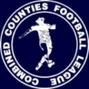
Cherry Red Records
Combined Counties League
Premier Division Table 2014/15
inc Weds. 28th January 2015 | P | W | D | L | F | A | Pts | GD | H | A
Camberley Town | 25 | 19 | 3 | 3 | 61 | 17 | 60 | +44 | 7/2 | 0-1
Cove | 27 | 18 | 5 | 4 | 64 | 42 | 59 | +22 | 7/3 | 0-1
Molesey | 23 | 18 | 0 | 5 | 68 | 20 | 54 | +48 | 1-3 | 28/2
Windsor | 27 | 17 | 3 | 7 | 66 | 35 | 54 | +31 | 0-5 | 11/4
Ashford Town (Mx) | 26 | 17 | 2 | 7 | 60 | 32 | 53 | +28 | 2-4 | 3-1
Spelthorne Sports | 24 | 14 | 2 | 8 | 52 | 39 | 44 | +13 | 4-3 | 3-0
Hartley Wintney | 26 | 13 | 4 | 9 | 36 | 41 | 43 | -5 | 21/2 | 1-2
Badshot Lea | 26 | 12 | 4 | 10 | 56 | 45 | 40 | +11 | 21/3 | 2-4
Farnham Town | 25 | 10 | 5 | 10 | 55 | 59 | 35 | -4 | 2-4 | 2-0
Mole Valley SCR | 26 | 10 | 5 | 11 | 49 | 60 | 35 | -11 | 1-0 | 5-2
Colliers Wood United | 25 | 10 | 2 | 13 | 45 | 44 | 32 | +1 | 4/4 | 2-3
Epsom & Ewell | 25 | 10 | 2 | 13 | 46 | 47 | 32 | -1 | - | -
Bedfont Sports | 24 | 9 | 3 | 12 | 33 | 45 | 30 | -12 | 0-1 | 2-0
Chertsey Town | 26 | 9 | 3 | 14 | 40 | 55 | 30 | -15 | 1-2 | 14/3
Raynes Park Vale | 24 | 7 | 5 | 12 | 33 | 44 | 26 | -11 | 0-1 | 14/2
Knaphill | 24 | 7 | 5 | 12 | 30 | 56 | 26 | -26 | 18/4 | 4-1
Westfield | 24 | 6 | 5 | 13 | 35 | 48 | 23 | -13 | 31/1 | 0-4
Horley Town | 25 | 6 | 5 | 14 | 47 | 66 | 23 | -19 | 2-2 | 6/4
Frimley Green | 26 | 5 | 4 | 17 | 42 | 73 | 19 | -31 | 0-0 | 25/4
Guildford City | 23 | 5 | 2 | 16 | 38 | 67 | 17 | -29 | 4-1 | 28/3
Hanworth Villa | 23 | 3 | 5 | 15 | 28 | 49 | 14 | -21 | 3/3 | 5-2

Lucky Day? – 31st January
Played 11 - Won 5 Drawn 0 Lost 6 - F 23 A 20 - PPG 1.36 - Average
Club record against Westfield
Played 15 - Won 10 Drawn 2 Lost 3 - F 36 A 26 - PPG 2.13 - Very Good
Their last visit
Tuesday 6th August 2013 - Won 2-1 - Combined Counties League

Anthony Panayi
Good afternoon!

Today we welcome Westfield to Hgh Road in what should be another good game.

After the disappointment last week of getting knocked out of the cup we are looking forward to getting back to winning ways!

Over the next few weeks we will have a few players back from suspensions and injuries something which has cost us this season.

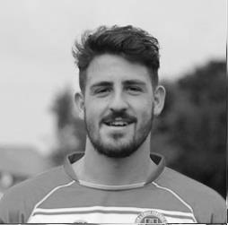
On that note all the boys want to say a big well done to 'trig' a.k.a. George Murphy for continuing to play through a double hernia! George will be missed in the team for the time he will be out for! We wish him a speedy recovery!

Thank you for your continued support!

COME ON YOU SALTS!

Ant

Results and Fixtures
F.A. Vase Fourth Round – Saturday 17th January
Ascot United | 4-2+ | Colliers Wood United
Combined Counties League – Saturday 17th January
Ashford Town (Mx) | 1-2 | Westfield
Cove | 1-3 | Badshot Lea
Epsom & Ewell | 2-4 | Farnham Town
Horley Town | 1-2 | Windsor
Mole Valley SCR | 0-4 | Chertsey Town
Raynes Park Vale | 1-1 | Hartley Wintney
Spelthorne Sports | 2-0 | Knaphill
Surrey Senior Cup Third Round – Tuesday 20th January
Molesey | 3-1 | Epsom & Ewell
Combined Counties League – Saturday 24th January
Badshot Lea | 3-0 | Ashford Town (Mx)
Camberley Town | 3-1 | Bedfont Sports
Chertsey Town | 0-3 | Spelthorne Sports
Hanworth Villa | 2-2 | Knaphill
Hartley Wintney | 3-1 | Frimley Green
Horley Town | 2-2 | Cove
Raynes Park Vale | 2-3 | Mole Valley SCR
Windsor | 2-4 | Farnham Town
Surrey Senior Cup Third Round – Tuesday 27th January
Redhill | 0-2 | Westfield
Results and Fixtures
Combined Counties League Cup Third Round – Tuesday 27th January
Farnham Town | 2-0 | Mole Valley SCR
Worcester Park | 6-1 | Banstead Athletic
Game played at Colliers Wood United
Combined Counties League – Tuesday 27th January
Cove | 3-0 | Frimley Green
Molesey | 3-1 | Windsor
Combined Counties League – Wednesday 28th January
Colliers Wood United | 0-1 | Camberley Town
Combined Counties League – Saturday 31st January
Ashford Town (Mx) | V | Colliers Wood United
Bedfont Sports | V | Horley Town
Epsom & Ewell | V | Westfield
Farnham Town | V | Raynes Park Vale
Frimley Green | V | Hanworth Villa
Hartley Wintney | V | Guildford City
Knaphill | V | Badshot Lea
Combined Counties League – Saturday 31st January
Mole Valley SCR | V | Camberley Town
Molesey | V | Cove
Spelthorne Sports | V | Windsor
Combined Counties League – Tuesday 3rd February
Badshot Lea | V | Hanworth Villa
Mole Valley SCR | V | Farnham Town
Molesey | V | Chertsey Town
Spelthorne Sports | V | Horley Town
Westfield | V | Bedfont Sports
Combined Counties League – Wednesday 4th February
Guildford City | V | Cove
Combined Counties League – Saturday 7th February
Ashford Town (Mx) | V | Hartley Wintney
Badshot Lea | V | Spelthorne Sports
Chertsey Town | V | Bedfont Sports
Colliers Wood United | V | Knaphill
Cove | V | Mole Valley SCR
Epsom & Ewell | V | Camberley Town
Farnham Town | V | Molesey
Guildford City | V | Horley Town
Raynes Park Vale | V | Hanworth Villa
Windsor | V | Westfield

First Eleven Appearances - (max 33 inc Molesey)
Name | Debut | 2014/15 |  |  |  | Career Totals
 |  | App | Sub | Total | Goals | App | Sub | Total | Goals
BROWN Oshane* | 30/08/2014 | 2 | 0 | 2 | 0 | 2 | 0 | 2 | 0
BURNS Robbie | 14/08/2007 | 0 | 1 | 1 | 0 | 202 | 15 | 217 | 121
COOPER-SMITH Daryl | 03/01/2015 | 4 | 0 | 4 | 1 | 4 | 0 | 4 | 1
CURRIE Sam | 04/08/2012 | 2 | 2 | 4 | 0 | 96 | 7 | 103 | 2
DEAN Dan | 02/08/2014 | 25 | 1 | 26 | 0 | 25 | 1 | 26 | 0
DEWAR Ali | 29/10/2011 | 5 | 6 | 11 | 3 | 55 | 35 | 90 | 10
DOUGLIN Karl* | 03/08/2013 | 1 | 0 | 1 | 1 | 41 | 3 | 44 | 14
DOWNS Carl* | 17/09/2011 | 4 | 1 | 5 | 0 | 94 | 13 | 107 | 2
EACOTT Michael | 02/08/2014 | 31 | 0 | 31 | 0 | 31 | 0 | 31 | 0
FARRELL Matt | 02/08/2014 | 28 | 3 | 31 | 3 | 28 | 3 | 31 | 3
FERDINANDO Matt | 20/09/2014 | 16 | 3 | 19 | 6 | 16 | 3 | 19 | 6
GAFFNEY Luke | 16/08/2014 | 10 | 1 | 11 | 0 | 10 | 1 | 11 | 0
HARPER Tommy* | 15/04/2014 | 1 | 0 | 1 | 0 | 2 | 1 | 3 | 0
HAYWARD Ben | 07/03/2007 | 6 | 0 | 6 | 0 | 242 | 28 | 270 | 18
HOADLEY Harry | 27/08/2011 | 6 | 1 | 7 | 0 | 7 | 1 | 8 | 0
HOUGH Kyle | 14/08/2007 | 28 | 2 | 30 | 16 | 282 | 14 | 296 | 153
JARMAN Mark | 08/08/2009 | 5 | 5 | 10 | 0 | 136 | 51 | 187 | 76
MARVELL Dale | 15/01/2000 | 11 | 5 | 16 | 5 | 261 | 45 | 306 | 85
MCGREGOR Alex | 08/08/2009 | 11 | 0 | 11 | 1 | 168 | 54 | 222 | 27
MCKAY Alex | 20/12/2008 | 7 | 4 | 11 | 1 | 72 | 26 | 98 | 8
MURPHY George | 28/03/2013 | 22 | 1 | 23 | 1 | 63 | 5 | 68 | 3
MUTIMA Lionel | 05/08/2014 | 4 | 2 | 6 | 0 | 4 | 2 | 6 | 0
NELMES Elliott* | 05/08/2014 | 2 | 0 | 2 | 0 | 2 | 0 | 2 | 0
PANAYI Anthony | 14/11/2010 | 25 | 1 | 26 | 0 | 152 | 15 | 167 | 4
PANAYIOUTOU Savva | 03/01/2015 | 4 | 0 | 4 | 1 | 4 | 0 | 4 | 1
ROBINSON Matt | 01/12/2012 | 15 | 1 | 16 | 2 | 16 | 4 | 20 | 3
ROBINSON Sam | 22/10/2011 | 18 | 1 | 19 | 6 | 42 | 4 | 46 | 11
ROWE Steve | 27/08/2011 | 7 | 0 | 7 | 0 | 12 | 1 | 13 | 0
SHAW Ollie | 20/09/2014 | 0 | 10 | 10 | 0 | 0 | 10 | 10 | 0
SMITH Matt | 08/08/2009 | 0 | 1 | 1 | 0 | 91 | 43 | 134 | 10
SMITH Taylor* | 02/08/2014 | 13 | 2 | 15 | 7 | 13 | 2 | 15 | 7
TANTON Matt | 02/08/2014 | 18 | 4 | 22 | 1 | 18 | 4 | 22 | 1
TAYLOR James | 26/08/2013 | 26 | 1 | 27 | 2 | 43 | 7 | 50 | 3
VAN GELDER Julian* | 12/09/2006 | 0 | 1 | 1 | 0 | 0 | 2 | 2 | 0
WHITE Sean* | 02/08/2014 | 6 | 13 | 19 | 3 | 6 | 13 | 19 | 3
Own Goal |  |  |  |  | 1
* Player has left the club

From behind the goal
Epsom & Ewell 2-4 Farnham Town
Combined Counties League - Saturday 17th January 2015

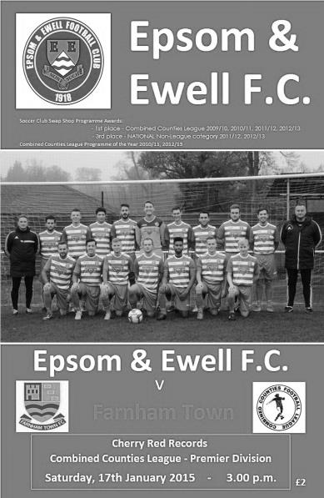
Consistency proving elusive for Salts

Saturday's home defeat to in-form Farnham Town ensures that our last six matches have finished; win, loss, win, loss, win, loss! Extended further, after 22 games under Glyn Mandeville we have won eleven and lost eleven with an even goal difference!

At least the line-up was consistent as we named an unchanged side, following our fine win at Ashford Town and hopefully could take any momentum from that game into this latest match. Unfortunately Farnham hadn't read the script and produced a fine performance of their own, full of attacking pace and threat, the like of which we hadn't come up against since visiting Lingfield in November.

The opening exchanges were even and we could have gone ahead in the seventh minute when Daryl Cooper-Smith sent a pinpoint pass from twenty yards into the path of Savva "Agi" Panayiotou. As he advanced on goal he chose to shoot from just inside the box and went high instead of low but keeper Danny Leeds was able to deflect the shot just over the bar. From the corner the ball dropped to George Murphy who timed his shot perfectly, but unfortunately for him and the crowd, his strike fizzed a matter of inches wide of the top corner.

Next in action was Michael Eacott who had to be alert to block an effort from down the left wing but he had no chance in the 15th minute when a low right wing cross was headed in at the near post by John Lancashire. This was a disappointing start but it was almost instantly forgotten by the majority of the crowd as Cooper-Smith advanced on goal and from at least 25 yards struck a low shot that visibly swerved away from the keeper and into the bottom corner of the net. As at Ashford seven days previously we had dealt with conceding in the very best way, with a lightning quick response of our own.

Could we take advantage of the equaliser? Ultimately no. The visitors upped their game and started to attack us, mostly down the right flank where Steve Rowe was getting two players on him for virtually the remainder of the half and we didn't seem able to help him out. We had a warning after 32 minutes when a ball in from that area was met beyond the far post by a powerful strike that flew off our post and went out for a throw

on!

The warnings weren't heeded though and from yet another attack down our left flank the ball was held up and laid back for Mark Corbett to knock the ball into the far corner. We were up against it at this point as the visitors began to take full control. Another shot was deflected over the bar for a corner while another shot just moments later was blocked out for a corner by Anthony Panayi. However, on the counter attack in the 41st minute, a break down the left was laid back to Alex McKay who controlled the ball on the edge of the area and smashed the ball into the bottom corner with the keeper seeing the ball late.

Another scare came right on half time when a Farnham striker got through just ahead of Murphy and bore down on goal but Eacott did well to make an intervention with his leg, and although the striker was first to the loose ball and shot goalwards, Murphy had positioned himself on the line to make a right footed clearance.

You could argue that being level at half time was fortunate and bearing in mind that we actually trailed at half time on Farnham's two previous visits it was almost a bonus. We started the second half in a positive fashion but didn't really create too much and that would come back to haunt us later in the match. Cooper-Smith prodded the ball inches wide of the far post and an Alex McGregor free kick was curled just beyond the Farnham far post with the keeper beaten but after 68 minutes the visitors got away again on the right and a good overlapping run by the full back resulted in a low near post cross and although we were alert to block the incoming shot from Lancashire, the ball fell kindly for him to knock it into the net from close range.

The returning Robbie Burns made an entrance along with Ali Dewar as we replaced Matt Robinson and the injured Kyle Hough who had been having rough days, but after78 minutes Eacott was in action once again, denying the left winger and a minute later they had their fourth goal as Elliott Cardona was able to benefit from yet another low right wing cross to the near post.

Matt Farrell entered the fray for Murphy and Panayiotou had a shot deflected wide for a corner but in truth we didn't create as much as the visitors who were fully deserving of the three points over the ninety minutes and left the Salts looking for that elusive consistency which threatens to leave us right in the middle of the table

Team:
Michael Eacott, James Taylor, Steve Rowe, Anthony Panayi ©,
George Murphy, Savva Panayiotou, Alex McGregor, Alex McKay, Kyle Hough,
Daryl Cooper-Smith, Matt Robinson

Subs:
Ali Dewar for Robinson (74), Robbie Burns for Hough (74),
Matt Farrell for Murphy (79)

From behind the goal
Molesey 3-1 Epsom & Ewell
Surrey Senior Cup Third Round - Tuesday 20th January 2015

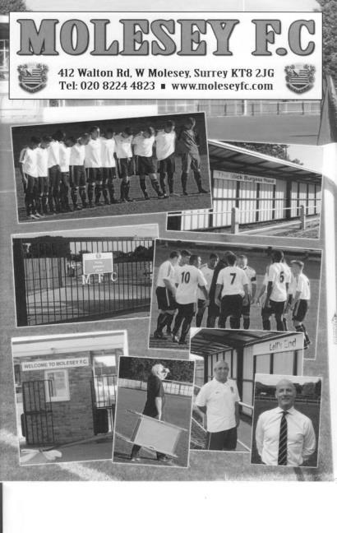
Moles wear Salts down in chilly cup tie

Molesey deservedly won this rearranged Surrey Senior Cup tie at a very cold Walton Road. However, with six minutes of normal time remaining the score was level and the tie could have gone either way.

We were able to include Matt Ferdinando in the line-up following the completion of his three match suspension although up front Kyle Hough was unable to get to the ground in time and this forced Glyn Mandeville into a change of plan up front, with Daryl Cooper-Smith leading the line and Alex McGregor playing behind him in a free role. Ferdinando and Matt Robinson took the wide berths in a 4-4-2 which looked quite threatening.

All we had to do now was to get hold of the ball, which proved quite difficult to start with. In fact Captain Anthony Panayi had to block a goalbound shot from close range in the first minute or we'd have got off to a horrible start. Another saving challenge on the left hand side of the defence restricted the home side to a corner as they came out with all guns blazing, probably frustrated at their late postponement on Saturday.

However, we began to weather the storm and got forward ourselves from time to time. James Taylor, making his 50th appearance produced a couple of crosses on a full back overlap as he linked well with Ferdinando and the prompting McGregor. However a few minutes later we were fortunate that a misplaced pass from a Molesey striker ran through to Michael Eacott instead of finding his well-placed team mate.

In the 27th minute we took the lead. Good work out on the right enabled the Molesey defence to get dragged over and the ball came to Robinson, who cut outside a covering defender and from the edge of the box unleashed a powerful shot that flew into the net off the far post. You could hear that there was a slight deflection on the shot but it was only a faint one and we were ahead. Unfortunately we were pushed back almost immediately, conceding a couple of corners, and from the second of these, Tom Windsor scored with a close range header while our players were claiming a foul on Eacott. The home side were getting the benefit of the decisions at this stage with a

couple of cynical fouls to stop Ferdinando runs going unpunished, while Cooper-Smith picked up the only yellow card of the opening forty five minutes for a challenge that appeared slightly late but happened right under the noses of the Molesey bench with predictable consequences.

Robinson tried his luck with a couple more long range efforts, although one was saved and one was wide, while McGregor curled a free kick over the bar, but on balance the home side shaded the first half which ended with the referee talking to Lewington the Molesey captain about the number of fouls they were conceding.

We had to make an early change in the second half with Steve Rowe limping off and being replaced by Ali Dewar. Versatile Dewar may be, but I think this was his first attempt for us at left back, which was also ironic as we had three to choose from in that position not so long ago. The home side appeared unlucky to get pulled up on an offside call while Robinson was again unfortunate to see his well struck shot just go beyond the far post after some good work by our midfield. This was quite a good time for us, although we created little of real threat, but the game was more even for a while.

As we entered the last twenty minutes the game became one of attack and counter attack. The home side pushed forward and Eacott did well to block a shot at the far post, but they were vulnerable to the break, and from one of these McGregor put Cooper-Smith through, but as he beat his man he was brought down by the Molesey number 2, and only the presence of a nearby covering defender ensured that the card was just a yellow one. McGregor then put a shot wide after Robinson's free kick was blocked to him.

Hough came on for the tiring Ferdinando but within a minute the home side had struck the killer blow, spreading the ball out wide to Windsor who scored his second of the night with a low drive into Eacott's far corner, and a third goal followed three minutes into injury time when we failed to control the ball in defence and it was fed back and then knocked past Eacott by James McShane before we could recover. Overall we have had two matches against Molesey now and both have seen us fall just a little short. They are a decent side that will almost certainly be right there at the end of the season. As for us, we get another chance at them in late February but now have eleven days off before hosting Westfield on 31st January.

Team: Michael Eacott, James Taylor, Steve Rowe, Anthony Panayi ©,
George Murphy, Savva Panayiotou, Matt Ferdinando, Matt Farrell,
Daryl Cooper-Smith, Alex McGregor, Matt Robinson

Subs: Ali Dewar for Rowe (50), Kyle Hough for Ferdinando (83)

Club Records - 31st January
Date | Day | Competition |  | Opponents |  | Scorers
31/01/25 | Sat | Surrey Senior League | A | Guildford | 1-4 | J.Wilson
31/01/31 | Sat | London League | A | Carshalton Athletic | 7-3 | G.Prestoe (3), H.Pattimore (3), T.Jones
31/01/48 | Sat | London League | H | Eton Manor | 0-2
31/01/53 | Sat | Surrey Senior Cup  Quarter Final | H | Dulwich Hamlet | 3-4 | D.Ford (2), I.Hughes
31/01/59 | Sat | Corinthian League | A | Leatherhead | 0-3
31/01/70 | Sat | Athenian League 2 | H | Leyton | 1-2 | S.Smyth
31/01/76 | Sat | Athenian League 2 | H | Willesden | 4-0 | T.Tuite (3), J.Eales
31/01/81 | Sat | Isthmian League 1 | H | Hertford Town | 2-0 | M.Cornwell (2)
31/01/87 | Sat | Isthmian League 1 | A | Staines Town | 3-0 | S.Hill (2), A.Mair
31/01/98 | Sat | Isthmian League 3 | H | Clapton | 0-1
31/01/09 | Sat | Combined Counties Premier Division | H | Sandhurst Town | 2-1 | R.Burns, D.Marvell
Historical Decades
90 years ago – Epsom Town
31/01/25 | Sat | Surrey Senior League | A | Guildford | 1-4 | J.Wilson
80 years ago – Epsom F.C.
02/02/35 | Sat | London League | A | Park Royal | 2-5 | H.Pullen (2)
70 years ago – War time Epsom Town
20/01/45 | Sat | Friendly | H | Royal Marines | 1-3 | A.Maynard
60 years ago – Epsom F.C.
29/01/55 | Sat | Corinthian League | H | Chesham United | 1-2 | J.Langley (pen)
50 years ago – Epsom & Ewell
30/01/65 | Sat | Athenian League 1 | A | Uxbridge | 0-5
40 years ago – Epsom & Ewell
03/02/75 | Mon | F.A. Vase 4 | A | Eastbourne Town | 2-0 | T.Lee, T.Tuite
30 years ago – Epsom & Ewell
29/01/85 | Tue | Surrey Senior Cup 1 | A | Whyteleafe | 2-1 | S.Hill (2)
20 years ago – Epsom & Ewell
04/02/95 | Sat | Isthmian League 3 | A | Southall | 1-2 | S.Smith
10 years ago – Epsom & Ewell
29/01/05 | Sat | Isthmian League 2 | H | Brook House | 0-3

History Corner – 31st January
84 years ago today George Prestoe scored a hat trick as we defeated Carshalton Athletic 7-3 at Colston Avenue in a London League match after the teams had been level at 2-2 at half time. He had joined us from Egham after playing well against us in a Surrey Senior Cup tie and he would get another hat trick the following week, but returned to Egham soon after this, only playing eight times for us.

70 years ago this week the Royal Marines made their first ever visit to West Street, defeating our boys 3-1 in a Friendly encounter. The Crystal Palace star Challis played against us while we gave debuts to two players, but an injury to Thomas left us with ten men for the final hour of the game.

62 years ago today we led the mighty Dulwich Hamlet 2-1 at half time of this Surrey Senior Cup Quarter Final and also led 3-2 with just ten minutes remaining, but with victory in our sights the Hamlet scored twice to reach the Semi-Final at our expense. However, we would get our revenge the following season. Denis Ford scored twice with the other goal from Ivor Hughes.

40 years ago this week we progressed to the last 16 of the F.A. Vase for the only time in our history when defeating Eastbourne Town 2-0 in a much postponed match. After a few attempts to play at the Saffrons, the game had to be played midweek, so neighbours Eastbourne United’s Princes Park was used as it had floodlights. Goals from Trevor Lee and Tommy Tuite ensured our progress to a home tie with Hornchurch.

39 years ago today Tommy Tuite scored three times and Johnny Eales got the other as we crushed Willesden 4-0 in an Athenian League match at West Street on our way to promotion. (see programme above)

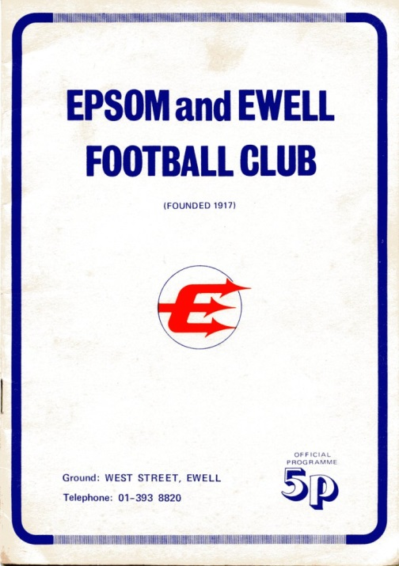
30 years ago this week we defeated Whyteleafe 2-1 in the Surrey Senior Cup. We led early through Steve Hill but the home side were level soon after this. Hill put us ahead again after just 7 minutes and that completed the scoring!

28 years ago today we were in a real scrap against relegation but Ricky Kidd’s rejuvenated side were going to have a real go at staying up. This day we defeated Staines Town by three clear goals at Wheatsheaf Lane with Steve Hill getting two and Alex Mair getting the third after a shot came back to him off the bar. Unfortunately we still went down by a single point.

Centre page for results

Centre page for results

Westfield F.C. – History
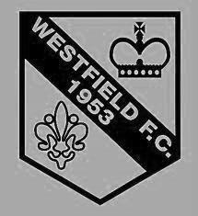
The Club was formed in 1953 as Westfield Boys Club playing in the Woking and District League and also running a youth team. From the start the Club had success in the competitions entered. Among the trophy’s won in the early years were the Surrey Youth Invitation Cup in 1953/54, the Surrey Junior Charity Cup in 1954/55 and 1955/56, the Surrey Junior Cup at the first attempt in 1955/56 and the Surrey Youth Cup in 1956/57.

Following several seasons in local league football the Club made the break into Surrey Intermediate Football using the present ground at Woking Park, Kingfield. Successes soon came and, after becoming League Champions and League Cup winners on several occasions in the subsequent seasons, the Club decided to apply for senior status.

The application was accepted in 1964 and after one season in the Parthenon League, Westfield met the necessary ground grading requirements and joined the Surrey Senior League.

Westfield’s future success in senior football sprang from their ability to attract the best local youngsters and they were successful in winning the Surrey Youth Cup again in 1966/67 and 1969/70 and the Surrey Youth Shield in 1969/70 and 1970/71. This talent matured and there followed three tremendous seasons for the senior side when they won the Surrey Senior League Cup in 1971/72, followed by the League and Cup double in 1972/73 and the League Championship again in 1973/74.

The Surrey Senior League was disbanded and reformed as the Combined Counties Football League in 1978 and Westfield became founder members and retained membership to date. Success, however, has been more difficult to achieve and in recent times the closest the senior team has come to honours was in 1989/90 when they lost the final of the Combined Counties League Cup to Hartley Wintney in extra time.

Season 2000/01 saw the Club enter the Carlsberg FA Vase for the first time, performing beyond expectations before losing in the Fourth Round to Ryman League Arlesey Town, on the way beating Wantage Town, Lewes and Bowers United.

Westfield continued to compete at youth level and they won the Combined Counties Youth League Cup in 1991/92 as well as being runners-up in the League.

Following the installation of floodlights in 1998 the U18 team joined the Southern Youth Floodlight League as members of the Western Division. The Club also run an U16 team playing in the West Surrey Youth League.

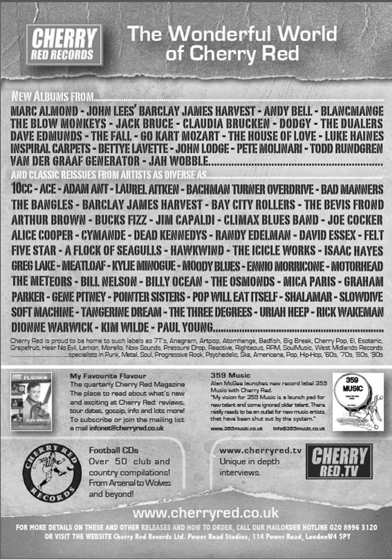

Player Sponsorship
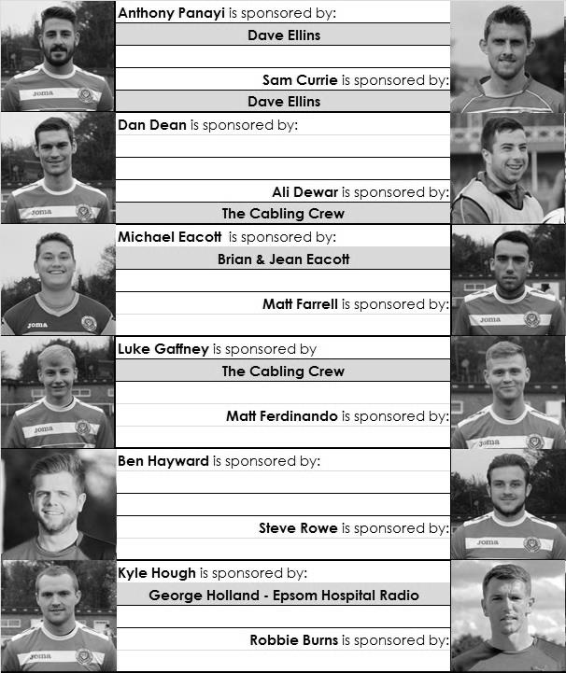

Here is the latest list showing all of the players and Management available for sponsorship. Sponsorship costs £40 so if you want to help the club, the player and get your name in the programme for the season, just let us know before they go!

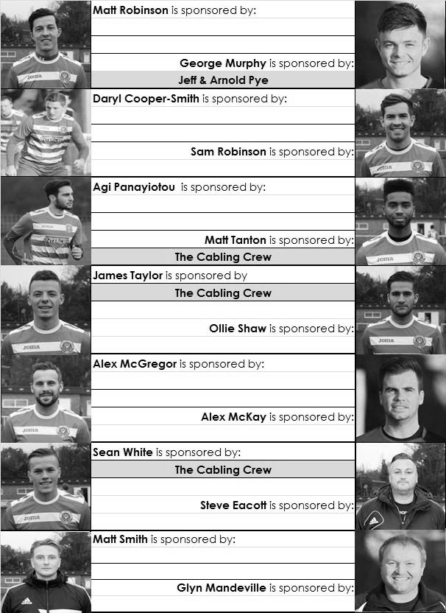

Every Opponent A-Z
Over the years we have played many, many different opponents. Exactly how many is a difficult question, as it all depends on your definition. Are Camberley & Yorktown different to Camberley Town, or are Epsom Town different to Epsom F.C. or Epsom & Ewell F.C.?

In my analysis I have classed them as the same team, and will work through them all from A to Z. Some we have played many times, whilst others we have met maybe just once or twice. Enjoy!

Metropolitan Police: Played 43 - W20 D7 L16 - F70 A74 - PPG - 1.56 - Above Average

People still find it strange that we should play a team at this level from the Metropolitan Police when every other “works” side has been eliminated from this level of football to my knowledge. Of course, all is not quite as it seems, as when I first started watching Epsom playing against them, they were restricted by the provision that you must be a police officer. Nowadays, this isn’t the case, which might explain why they are now an established Step Three team.

As with so many of our opponents, we actually started playing them far earlier than you might have thought. Our first ever meeting was way back on 12th November 1927 in an Amateur Cup tie at West Street. We were a decent outfit back then; two time Surrey Senior League Champions, and about to win the London League, but this did not affect them, and despite not being members of a League and just playing friendlies, they defeated us 3-0!

They joined the Spartan League in 1928 and we managed to squeeze past them in our next Amateur Cup meeting in the 1931/32 season when we were good enough to reach the Second Round Proper, but at Imber Court, their home since formation in 1919 they gained revenge the following season by knocking us out of both National Cups; two rounds short of the First Round Proper of the F.A. Cup (1-3) and in the final qualifying round of the Amateur Cup (2-5).

Results continued to favour the “Met”. We won a Surrey Charity Shield match in 1933, but were again knocked out of the F.A. Cup after a replay in 1935. They did it again later that same season in the Surrey Senior Cup by four goals to three and it was clear that they were becoming a bogey side, as we were pretty good ourselves in the thirties.

Our final pre-war meeting was another Surrey Senior Cup tie on 22nd January 1938 which we won 4-1 at West Street but following the war it was the same old problem as they won another F.A.Cup tie 5-0 at West Street in September of 1946.

We finally won another F.A. Cup tie 2-1 at Imber Court in September 1953 and didn’t then meet for five days short of ten years when they won a Surrey Senior Cup tie 3-1 in East Molesey. From that 1963 meeting we “lost touch” as they went through the Metropolitan and then Southern Leagues before arriving in the newly former Isthmian League Division Two for 1977/78. The two teams were at the top of the League throughout the season and we opened our floodlights against them on 24th August

1977, winning 1-0 and drawing the return 1-1 in February 1978. This made all the difference as we won the League title, while the Met Police were runners up.

Both teams spent six further seasons in competition as members of the Isthmian League Division One. We won the first six of these matches before losing four of the last six, including two 3-0 defeats in our promotion season of 1983/84. In the process ending our unbeaten home League run at 24 matches in March of 1984.

We came down again to Division One for 1986/87 but they were by then in Division Two South, having been relegated in 1984/85. We did meet in the Surrey Senior Cup though, edging through 2-1 at Imber Court. The following season it was their turn for success as they went up as Champions, only losing two games all season. We handed them their first defeat on the opening day of the season 22nd August 1987 when the weather was so bad that some games in the South East were abandoned! We trailed three times and led for just ten seconds, courtesy of Gary Greenaway’s long range strike in injury time. We then secured a 1-1 draw over there in February, although they did beat us 3-0 in the F.A. Cup, so you could say honours were even!

Despite them being at a higher level we knocked them out of the F.A. Cup 2-0 in September 1989 with the main memory being a Neil Robson strike before they knocked us out of the Associate Members Trophy (0-1) and the Surrey Senior Cup (1-2) in January 1997 and October 2000 respectively.

Our final four meetings came as members of the Isthmian League Division One South from 2002/03. We defeated them 1-0 on opening day and by the same score at Merland Rise but they won 5-2 at ours the following season although a great strike from youngster Craig Watkins nearly earned us a 2-1 win and we had to settle for a draw with a late equaliser before going down and never meeting since.

Since then they have had promotion to Step Three and recently reached the First Round of the F.A. Cup. At their excellent venue that of course these days now has a fourth floodlight pylon, things look well set for the Met.

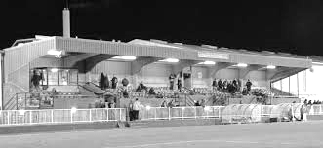
The main stand at Imber Court

Surrey Senior Cup
Third Round
Merstham | 2-1 | Sutton United
Redhill | 0-2 | Westfield
Dorking Wanderers | 3-4 | Colliers Wood United
Molesey | 3-1 | Epsom & Ewell
Leatherhead | 2-3 | Ashford Town (Mx)
Metropolitan Police | 3-0 | Chipstead
Tooting & Mitcham United | 3-1 | Mole Valley SCR
Corinthian Casuals | 17/2 | Badshot Lea
Quarter Finals
Ashford Town (Mx) | V | Westfield
Colliers Wood United | 18/2 | Merstham
Molesey | V | Corinthian Casuals / Badshot Lea
Met Police | V | Tooting & Mitcham United

F.A. Vase - Fifth Round – 7th Februuary
Bradford Town | V | Highworth Town
AFC St Austell | V | Stanway Rovers
Ascot United | V | Norwich United
Shaw Lane Aquaforce | V | Flackwell Heath
Glossop North End | V | Dunston UTS
Holbeach United | V | Erith & Belvedere
North Shields | V | Phoenix Sports
AFC Mansfield | V | Tadcaster Albion

Combined Counties League Premier Challenge Cup
Third Round
Westfield | 10/2 | Cove
Badshot Lea | 5-0 | Guildford City
Worcester Park | 6-1 | Banstead Athletic
Farnham Town | 2-0 | Mole Valley SCR
Frimley Green | 0-5 | Epsom & Ewell
Windsor | 8-1 | Ash United
Colliers Wood United | 3-2 | Horley Town
Camberley Town | 3-0 | Ashford Town (Mx)
Quarter Finals
Colliers Wood United | 25/2 | Badshot Lea
Worcester Park | V | Windsor
Epsom & Ewell | 24/2 | Camberley Town
Farnham Town | V | Westfield / Cove

Match and Ball Sponsorships – 2014/15
Opponent | Date | Match Sponsor | Ball Sponsor
Raynes Park Vale | 05/08/14 | Club President - Stella Lamont
Horley Town | 25/08/14 | EEFC Management Committee
Croydon (FAC) | 30/08/14 | EEFC Media Officer - Richard Lambert
Frimley Green | 13/09/14 | Dave Gaffney and friends
Guildford City | 30/09/14 | The Jarman family
Mole Valley SCR | 07/10/14 | Mark and Carmel Murphy
Bedfont Sports | 11/10/14 | Epsom & Ewell F.C. Colts
Knaphill (LC) | 14/10/14 | Geoff and Steve Dyke
Ashford Town (Mx) | 18/10/14 | The Building Shop, Bookham
Chertsey Town | 28/10/14 | In Memory of Bob Bexley
Molesey | 22/11/14 | The Cabling Crew 0208 -224 4110
Camberley Town (SSC) | 02/12/14 | In memory of Liz and Doug Burns
Spelthorne Sports | 16/12/14 | long serving supporter Paul Merritt
Windsor | 03/01/15 | Ezara Beddoe
Farnham Town | 17/01/15 | In memory of Chris Henry
Westfield | 31/01/15 | Former player Marvin Hough
Camberley Town | 07/02/15
Hartley Wintney | 21/02/15
Camberley Town (LC) | 24/02/15
Hanworth Villa | 03/03/15
Cove | 07/03/15
Badshot Lea | 21/03/15
Colliers Wood United | 04/04/15
Knaphill | 18/04/15
For League, League Cup and Surrey Senior Cup Matches:

Match sponsorship - £40.00 Match ball sponsorship - £25.00.
Combined Offer of Match and Match Ball sponsorship for £55.00.

For F.A. Cup and F.A. Vase matches:

Match sponsorship - £50.00 Match ball sponsorship - £30.00.
Combined Offer of Match and Match Ball sponsorship for £65.00.
----------------------------------------------------------------------------------------------------------------------------
Sponsorship includes

Admission, programmes, advertising (if required) and hospitality.

If you are interested, just speak to a Committee Member, you know where we are!
Alternatively, drop me an email at: richard.c.lambert@gmail.com

Salts Super Six Predictor
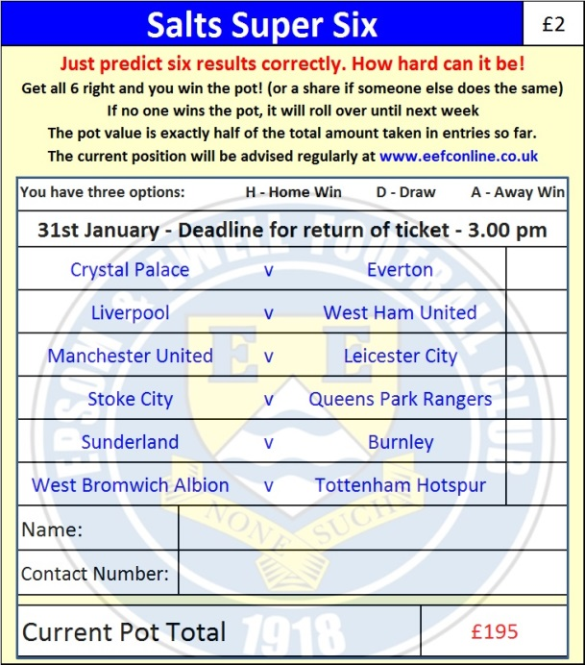
The Salts Super Six Predictor is live again and the next matches are on Saturday 31st January. Tickets are on sale at today’s game.

The competition is easy to play and you don’t even have to be at the match! To win, you simply need to predict the results of six matches correctly from the three options, fill in the form and make sure it is back with one of our distributors before the deadline on the ticket. The latest fixtures are shown here. Last week we had TEN entrants with five winning results so it surely won’t be long…

If you are a club regular, you just need to place your name on the sheet, although if you aren’t, then we’ll need a contact number from you too. We will announce any winners on the website within three working days, so don’t worry, we won’t miss you!

The prize pot is currently £195 but will continue to go up, if unclaimed, by the cost of 50% of all the sold tickets. In other words, if we sell 100 tickets at £2 before the deadline, and the pot isn’t won, then the next prize would be £295! You’ll always know the size of the pot before you enter.

Please note that if there is more than one winner, the prize pot would be shared between the winners. All you need to do now is have a go, as many times as you like!

Good luck!

Combined Counties League – Premier Division
Saturday, 31st January 2015 - Kick-off 3.00 p.m.
Epsom and Ewell  (Royal Blue & White hoops) | V |  | Westfield  (Yellow / Black / Black)
 | NUMBERS
Michael Eacott |  |  | Stuart Norman
James Taylor |  |  | Robert Parrott
Steve Rowe |  |  | Phil Moore
Anthony Panayi |  |  | Matt Steer
George Murphy |  |  | George Rowley
Dan Dean |  |  | Luke Beale
Matt Ferdinando |  |  | Shane Cheeseman
Matt Farrell |  |  | Adam Beale
Kyle Hough |  |  | Michael Milne
Alex McGregor |  |  | James Mariner
Matt Robinson |  |  | Dale Burnham
Daryl Cooper-Smith |  |  | Matt Jackson
Alex McKay |  |  | James Mepham
Sam Robinson |  |  | Daryn Hennessey
Matt Tanton |  |  | Jack Hollins
Savva ‘Agi’ Panayiotou |  |  | John Brawley
Sam Currie
Ali Dewar
Robbie Burns
Ben Hayward
Glyn Mandeville | MANAGER |  | Dan Snare
Matt Smith | ASSISTANT |  | Dave Powell
Steve Eacott / Alex McKay | COACHES |  | Mike Brawley
Ken Jones | PHYSIO |  | John Steerwood
REFEREE: L.Pinto Nunes (Kingston)
ASSISTANTS: W.Ingram (New Malden), R.Wells, (Coulsdon)
Today’s Match and Match Ball are sponsored by former player Marvin Hough, father of striker Kyle

OUR NEXT VISITORS TO HIGH ROAD
Camberley Town
Saturday 7th February 2015 - Kick-off 3.00 p.m.
Combined Counties League – Premier Division

